
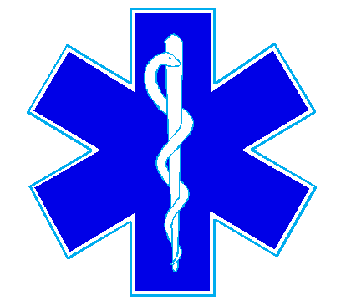
Nueces County Emergency Services District #4
Bluntzer Fire Department/EMS
5781 FM 666
Robstown, TX 78380
Office (361)387-4066

January 19, 2022

There was not a quorum for the January 19, 2022 meeting.

