
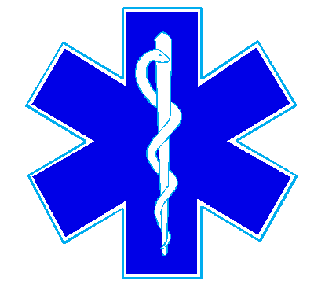
Nueces County Emergency Services District #4
Bluntzer Fire Department/EMS
5781 FM 666
Robstown, TX 78380
Office (361)387-4066

December 11, 2024

There was not a quorum for the December 11, 2024 meeting.

