Nueces County Emergency Services District #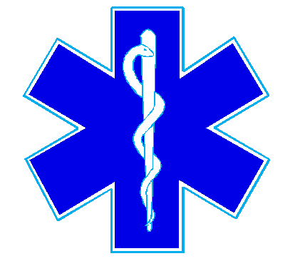4

Bluntzer Fire Department/EMS

5781 FM 666

Robstown, TX 78380

Office (361)387-4066

August 19, 2024

This was a meeting with the proposed architect. There was no quorum present.