
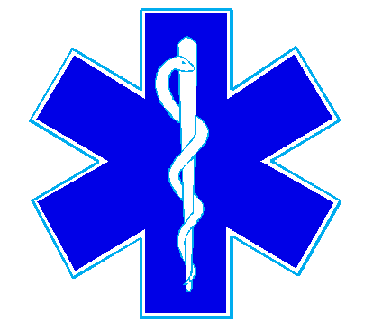
Nueces County Emergency Services District #4
Bluntzer Fire Department/EMS
5781 FM 666
Robstown, TX 78380
Office (361)387-4066

There was no quorum for the July 19, 2023 meeting.

